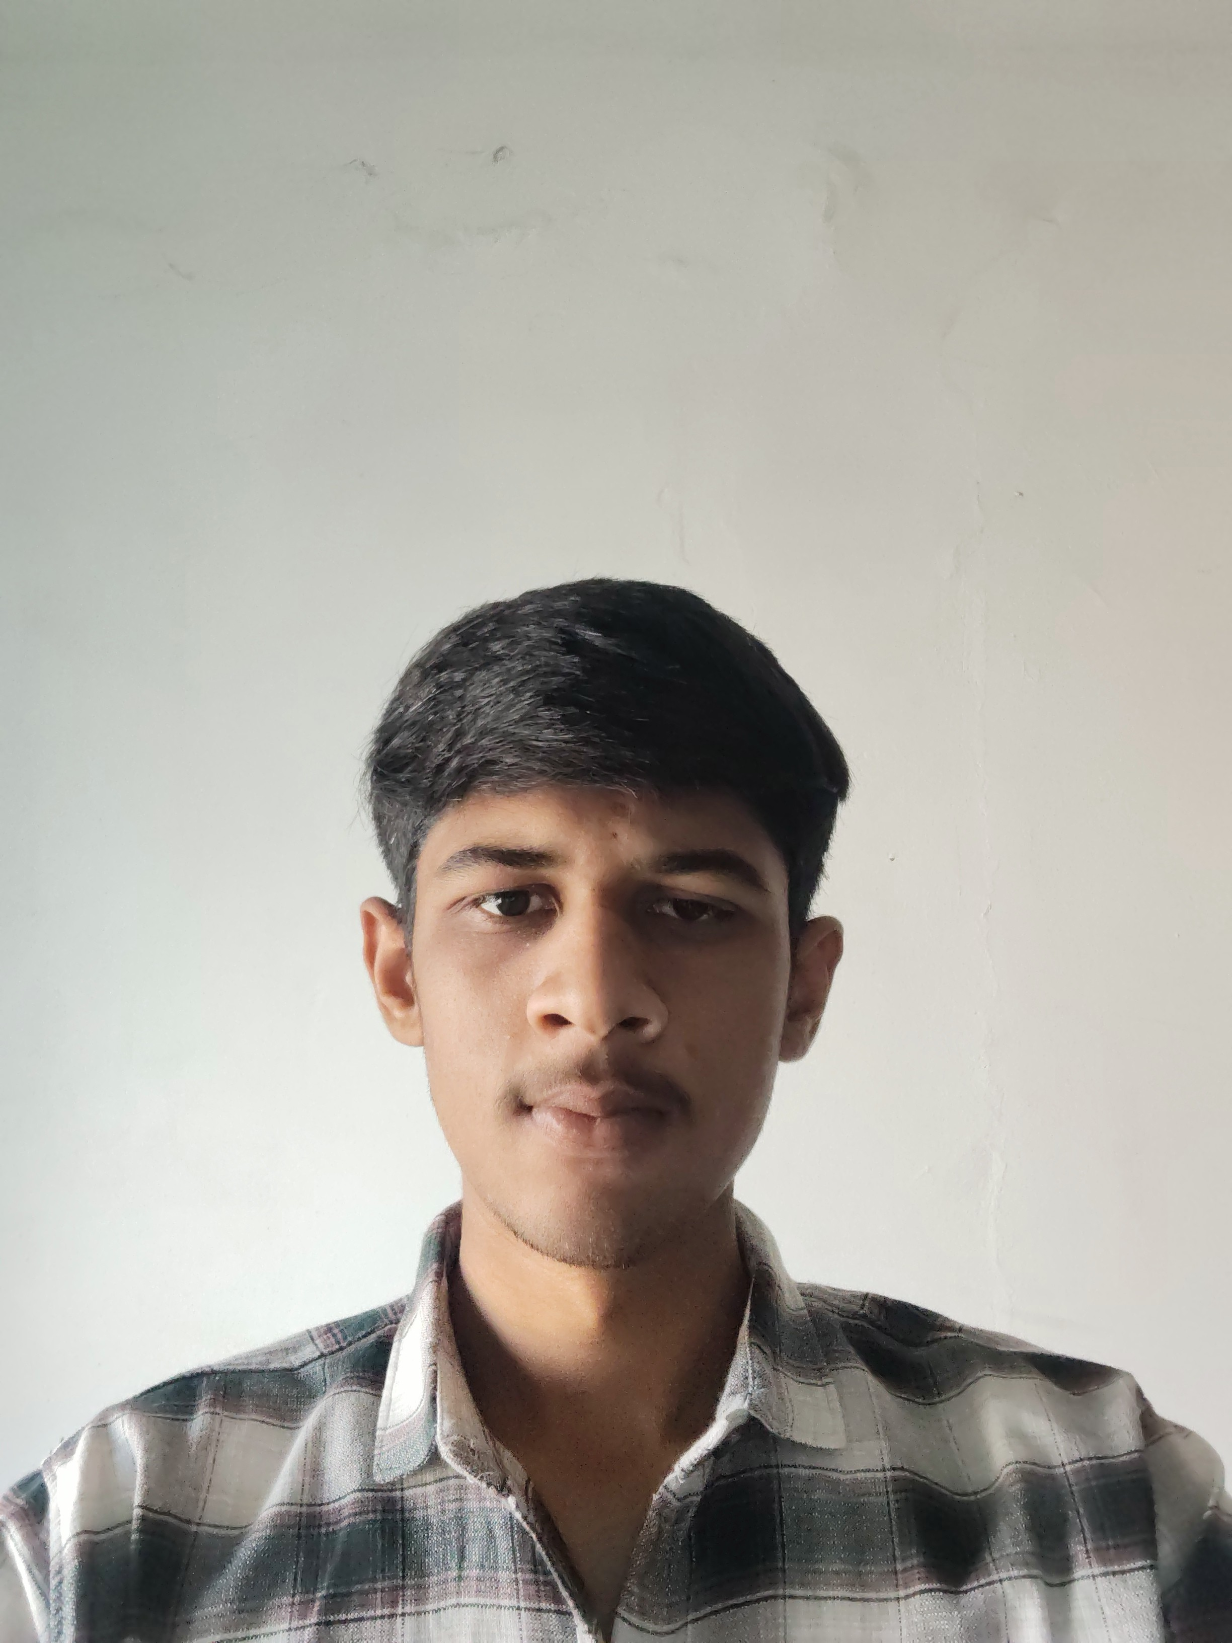
RESUME
Kandoriya Vishal Kishorbhai
2 Main Bajar Butavadar Jamnagar - 360480
Mobile No.: 9104570809
Email Id: ahirv2641@gmail.com

LinkedIn id 🔗: https://www.linkedin.com/in/kandoriya-vishal-7186803b0
CAREER OBJECTIVE
To make contribution in the organization with best of my ability and also to Develop new skills during the interaction to achieve new heights.

Education QUALIFICATION

No. | Qualification | University / Board | Year | Per %
1 | BCA | Saurashtra University | 2025-26 | Pursuing
2 | 12th | Gujarat secondary and higher secondary education board | 2022-23 | 77.71
3 | 10th | Gujarat secondary and higher secondary education board | 2020-21 | 74

OTHER QUALIFICATION DECLARATION
Basic knowledge of computer I hereby declared that the above Infor-
motion given by me is true to best of my
LANGUAGE KNOWLEDGE knowledge
Gujarat, Hindi and English
Nationality
HOBBY Indian
Time management
Gender
Work experience: no experience male

